PROPOZYCJE Z JĘZYKA ANGIELSKIEGO GRUPY STARSZE

SŁOWNICTWO:
house-dom
kitchen – kuchnia

bathroom – łazienka

chimney-komin

wall(s)-śniana(y) stairs-schody

window(s)-okno(a) garage-garaż

door -drzwi

roof-dach

1) MY HOUSE/TALKING FLASHCARDS-MAPLE LEAF LEARNING 1:24
https://www.youtube.com/watch?v=mTSUSkSgvE4&t=2s

2) KIDS VOCABULARY-HOUSE-PARTS OF THE HOUSE-LEARN ENGLISH FOR KIDS-ENGLISH EDUCATIONAL VIDEO-ENGLISH SINGSING 5:55
https://www.youtube.com/watch?v=R9intHqlzhc&t=23s

3) SUPER SIMPLE LEARNING COLORS LEARN BASIC COLOURS WITH BALLONS FOR KIDS TODDLERS BABIES PRESCHOOL-BINKLEBEE 1:56
https://www.youtube.com/watch?v=9Gp3t70V710&t=6s
PIOSENKI:
1) SKIDAMARINK(ANIMATED VERSION)/SUPER SIMPLE SONGS 2:27
https://www.youtube.com/watch?v=ug1pI-Ephns

2) THE MONTHS CHANT/SUPER SIMPLE SONGS-KIDS SONGS 2:18
https://www.youtube.com/watch?v=gtc4c1JlAEM

HISTORYKI:
1.MY HOUSE-STORY FOR KIDS CHILDREN/KIDS TV-NURSERY RHYMES&CHILDREN’S SONGS 3:35 https://www.youtube.com/watch?v=8Yfc_bQuGrM

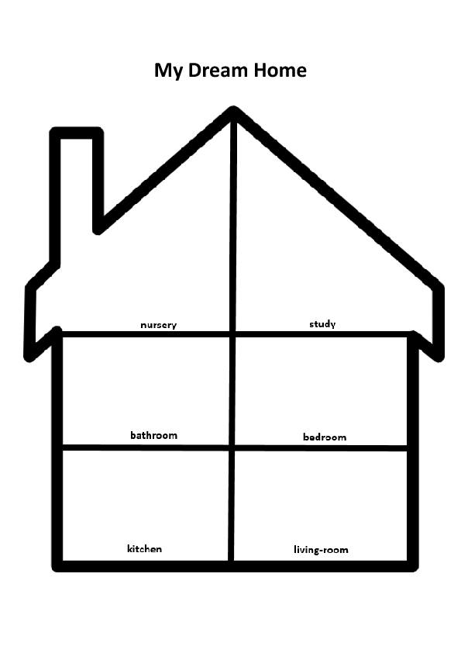

Narysuj swój wymarzony dom



